Problem definition
The hot exhaust gases of an engine that get redirected to the intake by the EGR system need to pass through a cooling device before entering the intake manifold for optimal performance. This can be modelled as a heated flow passing through a cooled cylinder with a series of baffles installed to create turbulence, slowing down the flow, resulting in a lower gas outlet temperature.

Sketch
Inlet: constant velocity u = 5m/s, constant temperature T_flow_in = 600○C
Wall: no-slip BC, constant temperature T_wall = 40○C
Baffles: no-slip BC, constant temperature T_baffles = 40○C
Outlet: zero-gradient for v, T, specified P
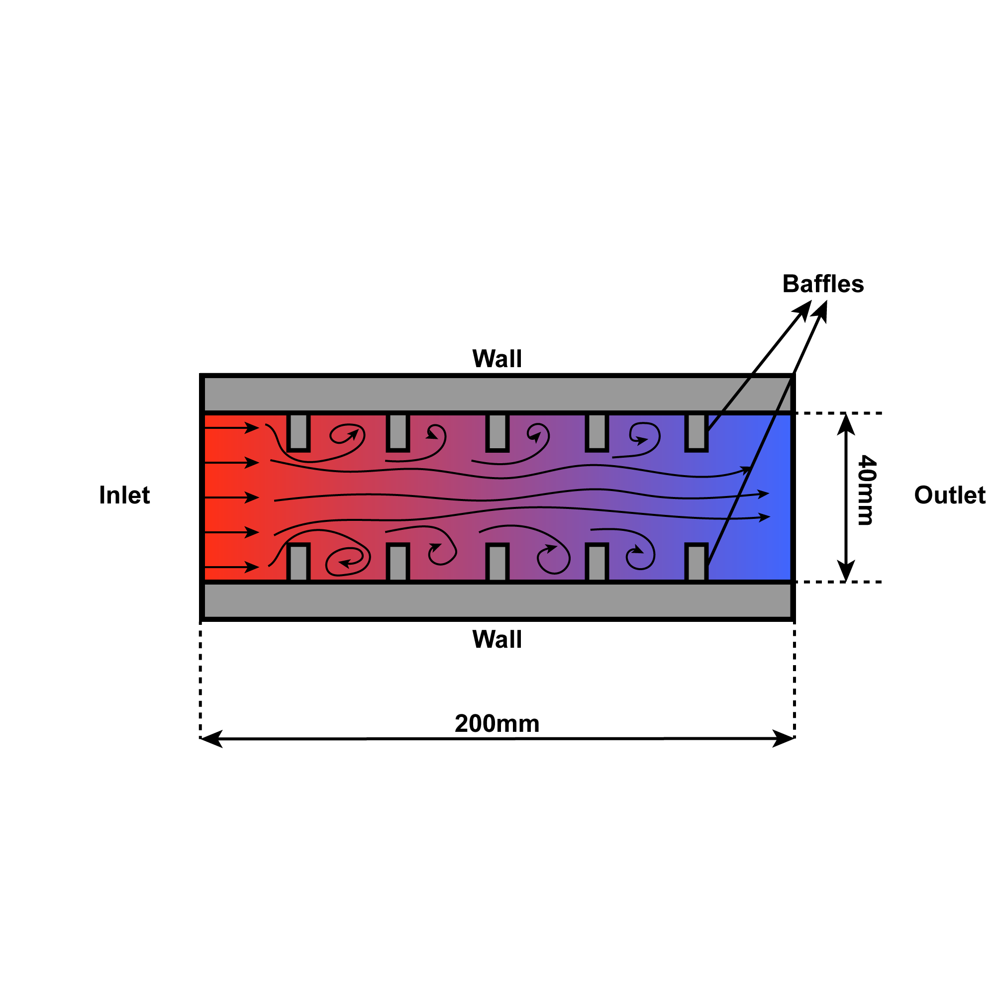

Transport equations
Equations: Continuity, Navier-Stokes (Momentum), Energy, Turbulence Model
Variables: u, v, T, P, ρ, k, ɛ
Research questions
What are the research questions you’d like to answer in this assignment?
e.g. 1. What is effect of the inlet gas velocity on the velocity field of the column?
2. What is the effect of internal baffle on the velocity field and temperature field?
3. What is the role of a turbulent model in this simulation?
…
- What is the specific effect of varying the inlet velocity on the final mass-averaged outlet temperature?
- How does varying the internal baffle height alter the ratio between the total pressure drop and the total temperature reduction across the cooler?
- How does the physical length of the turbulent recirculation zone behind each baffle dictate the local convective heat transfer rate at the water jacket boundary?

